Feedback QR codes and links
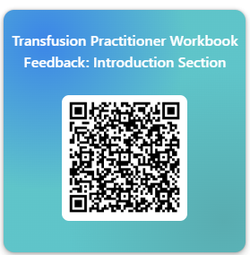
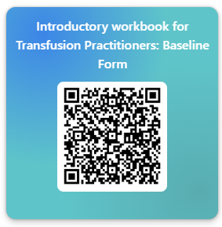

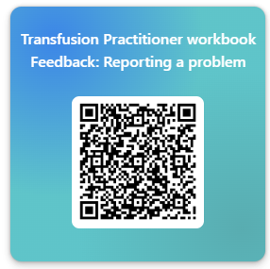
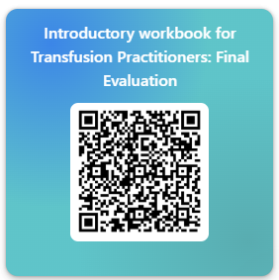
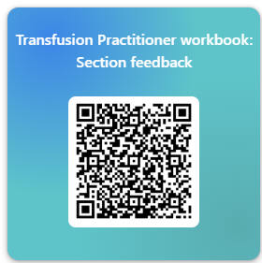
Transfusion Practitioner workbook Feedback: Reporting a problem – Fill in form
Introductory workbook for Transfusion Practitioners: Final Evaluation – Fill in form
Transfusion Practitioner workbook: Section feedback – Fill in form
Transfusion Practitioner Workbook Feedback: Introduction Section – Fill in form
Introductory workbook for Transfusion Practitioners: Baseline Form – Fill in form

